DATA STRUCTURES AND ALGORITHMS PROJECT REPORT


Course: Data Structures and Algorithms
Topic: SUDOKU GAME ENGINE WITH AI SOLVER & GENERATOR

Instructor 1: Prof. Ho Van Long
Instructor 2: Thai Trung Tin

Team member:

Student ID | Student Name
ITCSIU24034 | Phạm Gia Huy
ITCSIU24041 | Giáp Đăng Khoa

Contents
1. Introduction 4
1.1 Project Overview 4
1.2 Objectives 4
1.3 Scope 4
1.4 Features 4
2. System Design 4
2.1 Architecture Overview 4
2.2 Class Diagram Concept 4
2.3 Module Design 5
3. Data Structures 5
3.1 2D Arrays (Matrices) 5
3.2 LIFO Stack (std::vector) 5
3.3 State Stack (State Machine Pattern) 5
3.4 Bitmasks (uint16_t) 6
3.5 std::optional 6
4. Algorithms & Optimization Analysis 6
4.1 Randomized Backtracking (State-Space Search) 6
4.2 Minimum Remaining Values (MRV) Heuristic 7
4.3 Bitwise Constraint Propagation (Hardware-Level Optimization) 7
4.4 Arc Consistency 3 (AC-3) & Forward Checking 8
4.5 Time and Space Complexity Summary 9
5. GUI Design and State Management 11
5.1 The State Machine Stack 11
5.2 User Interface Layout 11
6. Implementation Details 16
7. Experimental Results 16
7.1 Solver Performance 16
7.2 Puzzle Generation Time 17
7.3 Difficulty Statistics 17
8. Challenges and Solutions 17
8.1 The std::bad_optional_access Crash 17
8.2 UI Thread Blocking 17
8.3 State Data Integrity 17
9. Conclusion 18
9.1 Achievements 18
9.2 Future Improvements 18

1. Introduction

1.1 Project Overview
The Sudoku Project is a comprehensive, desktop-based graphical application developed in C++ using the SFML library. It is not merely a digital board game but a sophisticated Constraint Satisfaction Problem (CSP) engine. It features a fully automated AI generator capable of creating puzzles of varying difficulties and an AI solver that mimics human deduction logic.

1.2 Objectives
- To practically apply advanced Data Structures and Algorithms (DSA) such as Backtracking, Graph-based propagation, and Heuristics.
- To optimize algorithms to run in real-time (under a few milliseconds) using Bit-manipulation.
- To implement a robust software architecture (State Machine Pattern) for UI management.

1.3 Scope
The project encompasses a playable Sudoku grid, real-time input validation, a dynamic difficulty classification system (Easy to Extreme), an Undo history system, and asynchronous puzzle generation to maintain UI responsiveness.

1.4 Features
- Dynamic puzzle generation with unique solutions.
- Real-time mistake tracking and "Second Chance" mechanics.
- Undo, Erase, Hint, and full Solution reveal.
- Multi-threaded generation preventing GUI freezing.
- 6 distinct difficulty levels categorized by algorithmic cognitive cost.

2. System Design

2.1 Architecture Overview
The system follows a modular architecture inspired by the Model-View-Controller (MVC) paradigm:
- Model (Core & AI): Manages game logic, data matrices, and heavy algorithmic computations (Board, SudokuSolver, SudokuGenerator).
- View (GUI): Renders the SFML components (SudokuGrid, GameUI, DifficultyBar).
- Controller (States): Handles user inputs and state transitions (Application, PlayingState, StateStack).

2.2 Class Diagram Concept
- Application owns a StateStack.
- StateStack dynamically manages State objects (e.g., MainMenuState, PlayingState).
- PlayingState orchestrates the Board, UI overlays (WinScreen, GameOverScreen), and invokes SudokuGenerator.

2.3 Module Design

2.3.1 Core Module
The Board class encapsulates the 9x9 grid, tracks mistakes, and manages the LIFO stack for the Undo feature.

2.3.2 Solver Module
A stateless utility class that evaluates a board's difficulty by simulating a human solving process, recording metrics like recursion depth and backtracks.

2.3.3 Generator Module
A background worker that utilizes random number generation (Mersenne Twister), digging algorithms, and AC-3 constraint propagation to guarantee unique solutions.

2.3.4 GUI Module
Built on SFML, it separates screens into distinct objects, utilizing callbacks (std::function) to communicate with the Core module, ensuring loose coupling.

3. Data Structures
The project heavily relies on specific data structures to optimize performance.

3.1 2D Arrays (Matrices)
- Usage: Cell grid[9][9] and int mSolution[9][9] in the Board class.
- Justification: Sudoku is inherently a grid. A 2D array provides 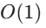 constant time complexity for accessing, updating, and verifying any specific cell based on its 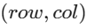 coordinates.

3.2 LIFO Stack (std::vector)
- Usage: The Undo system (std::vector<MoveRecord> mUndoStack).
- Justification: The Undo mechanic dictates that the last move made must be the first one undone (Last-In, First-Out). std::vector is used to simulate a stack, providing  time complexity for push_back() (saving a move) and pop_back() (reverting a move).

3.3 State Stack (State Machine Pattern)
- Usage: GUI screen management (StateStack class).
- Justification: Instead of loading all screens at once or using messy if-else flags, the application pushes states (e.g., Playing State over Main Menu State) and pops them. This prevents memory leaks and ensures that only the top-most state is updated and rendered.

3.4 Bitmasks (uint16_t)
- Usage: Constraint arrays in SudokuSolver (uint16_t rows[9], cols[9], blocks[9]).
- Justification: Instead of iterating through arrays to check if a number exists (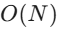), a 16-bit integer uses its bits to represent numbers 1-9. This reduces constraint checking to a single bitwise AND operation, shrinking the space and time complexity drastically.

3.5 std::optional
- Usage: Representing cell values (std::optional<int> value).
- Justification: A modern C++ feature that safely distinguishes between a cell containing the number '0' and an explicitly empty cell (std::nullopt), preventing logical bugs in the solver.

4. Algorithms & Optimization Analysis
The core of this project lies in the sophisticated handling of the Sudoku puzzle, which is intrinsically an NP-Complete Constraint Satisfaction Problem (CSP). A naive brute-force approach would cause immediate UI freezing and catastrophic performance degradation. Therefore, several advanced algorithmic optimizations were rigorously applied in SudokuSolver.cpp and SudokuGenerator.cpp.

4.1 Randomized Backtracking (State-Space Search)
- Algorithm Mechanism: Used primarily in SudokuGenerator::fillBoard(). Backtracking is a Depth-First Search (DFS) algorithm across the state space of the board. It attempts to place a number in a cell; if it violates constraints, it rolls back (undoes the placement) and tries the next candidate.
- The Optimization: Instead of iterating through candidate numbers sequentially (), the algorithm utilizes std::shuffle coupled with the std::mt19937 (Mersenne Twister) pseudo-random number generator.
- Why this is an Optimization:
  - Algorithmic Variety: In puzzle generation, sequentially attempting always produces identically structured initial grids, stripping the game of randomness. Randomizing the domain guarantees billions of unique, valid complete boards.
  - Avoiding Worst-case Determinism: Standard DFS can get trapped in deep "dead-end" branches of the search tree where sequentially bad guesses cost massive CPU time. Randomization disperses the probability of hitting these deterministic worst-case paths, improving average-case time complexity.

4.2 Minimum Remaining Values (MRV) Heuristic
- Algorithm Mechanism: Implemented in SudokuSolver::findMRVCell(). Instead of selecting the next empty cell sequentially (from top-left to bottom-right), the AI dynamically scans the entire board before every move. It calculates the number of valid candidates for each empty cell using bitwise constraint checking and selects the cell with the absolute minimum number of valid candidates remaining.
- Complexity Analysis of Finding the MRV Cell:
  - Time Complexity: Scanning the 81 cells takes  where is the number of empty cells (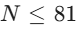). Because the candidate check is performed using  bitwise operations (~used & 0x1FF), the total time to find the best cell is strictly bound to  per recursive step.
  - Space Complexity:  auxiliary space. The function only uses a few primitive integer variables (minCandidates, bestRow, bestCol) to keep track of the minimum state.
- Mathematical Proof of Optimization (Why is it faster?):
This heuristic is based on the "Fail-First Principle". Let's assume a board has empty cells. In a standard Backtracking DFS, the time complexity is roughly bounded by 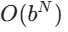, where is the average branching factor (number of valid guesses per cell, max 9).
  - Without MRV (Naive DFS): If the algorithm picks a cell with 9 choices, the search tree expands into 9 massive branches. If the first 8 branches are dead ends but only fail at depth 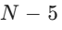, the algorithm wastes immense CPU cycles exploring doomed paths.
  - With MRV: The algorithm actively searches for cells where is as small as possible. If it finds a cell with only 1 choice (a Naked Single, 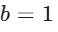), the branching factor for that node is 1. The recursion proceeds deterministically without branching:
  - Conclusion: By systematically minimizing at every depth level , MRV aggressively prunes the state-space tree. The theoretical worst-case remains exponential, but the practical average-case time drops from 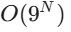 to roughly 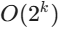, where 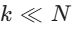, effectively eliminating unnecessary recursion and backtracking.

4.3 Bitwise Constraint Propagation (Hardware-Level Optimization)
- Algorithm Mechanism: Evaluating which numbers () can be safely placed in cell 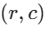.
- The Implementation: uint16_t used = rows[r] | cols[c] | blocks[b];
uint16_t available = ~used & 0x1FF;
- Is it an Optimization? YES, it is the most impactful low-level optimization in the project.
  - Naive Approach (Set/Array Iteration): To find if '5' is valid, the code must loop through 9 cells in the row, 9 in the column, and 9 in the block ( memory accesses and comparisons). This results in an  lookup.
  - Bitwise Approach: Each row, column, and block is represented by a single 16-bit integer (uint16_t). Number 1 is bit 0 (000000001), Number 9 is bit 8 (100000000).
  - By using Bitwise OR (|), we merge all used numbers. By using Bitwise NOT (~) and masking with 0x1FF (the first 9 bits), we instantly flip the bits to reveal all available numbers.
  - Performance Result: This reduces 27 loop iterations down to exactly 3 CPU instructions executed directly in the hardware registers. The lookup time drops from  to absolute  constant time.

4.4 Arc Consistency 3 (AC-3) & Forward Checking
- Algorithm Mechanism: Implemented in SudokuGenerator::propagateAC3() and fastCountSolutionsAC3(). This algorithm is specifically used to verify if a dug board has a unique solution (exactly 1 valid answer).
  - The board is modeled as a Constraint Graph. The 81 cells are Nodes, and the Sudoku rules (same row, col, block) form the Arcs (edges).
  - An array of 81 bitmasks (uint16_t domains[81]) maintains the "domain" (possible valid numbers) for every cell.
  - The AC-3 Queue: When a cell is assigned a number (its domain becomes 1 bit), it is pushed into a std::vector<int> queue. The algorithm pops a cell, retrieves its value, and uses bitwise operations to eliminate this value from the domains of its 20 interacting peers.
  - Ripple Effect (Forward Checking): If a peer's domain drops to a single remaining option after removal, that peer is immediately pushed into the queue. If any peer's domain drops to 0 (no options left), the algorithm instantly returns false (Unsolvable state).
- Complexity Analysis of AC-3:
  - Time Complexity: In the absolute worst case, each of the 81 cells can have its domain reduced at most 9 times. Every time a domain is reduced, we check its 20 peers. Thus, the maximum number of operations is strictly bounded by 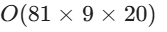, which is a constant . In generalized 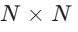 terms, AC-3 runs in polynomial time 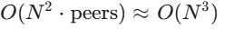.
  - Space Complexity: The domain state requires uint16_t domains[81], which takes exactly 162 bytes. The queue requires at most 81 integers. Thus, the space complexity is tightly bounded to space for a 9x9 grid.
- Mathematical Proof of Optimization (Why is it necessary for the Generator?):
When generating a puzzle, the system removes a cell and must answer the question: "Does this board still have ONLY ONE solution?"
  - Naive Approach (DFS only): The system would have to use backtracking to find the first solution, and then continue searching the entire remaining tree to ensure no second solution exists. Finding all solutions in an under-constrained board using DFS is computationally catastrophic .
  - AC-3 Approach: AC-3 acts as a powerful "Forward Checker". Instead of blindly guessing, it applies pure logical deduction. By eliminating impossible candidates via constraint propagation, AC-3 prunes vast sub-trees before the DFS algorithm even makes a single guess. For simple constraints, AC-3 solves the entire board without any recursion. If recursion is still needed, the search space is fractions of a percent of the original size.
  - Conclusion: Utilizing AC-3 shifts the computational burden from exponential searching 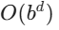 to polynomial constraint propagation 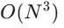, accelerating the unique-solution validation process by several orders of magnitude.
    - Understanding : In a standard Backtracking (DFS) algorithm, the time complexity is exponential , where (Branching Factor) is the number of valid choices per cell (up to 9 in Sudoku), and (Depth) is the total number of empty cells that need to be filled. For example, if a generated puzzle has 50 empty cells, the brute-force worst-case scenario demands a catastrophic operations.
    - The Paradigm Shift: AC-3 replaces this blind, exponential guessing game with pure polynomial deduction (). By logically eliminating invalid candidates across the entire board simultaneously before making any guesses, AC-3 drastically shrinks both and . It turns a potentially program-crashing recursive search into a lightweight, real-time operation.

4.5 Time and Space Complexity Summary
To clearly illustrate the optimizations achieved in this project, the following table summarizes the average time and space complexities of the various algorithms and data structures used:
Operation / Process | Algorithm / Data Structure | Time Complexity | Space Complexity
Board Initial Fill | Randomized Backtracking |  worst-case |  stack depth
Constraint Checking | Bitmasking (uint16_t arrays) |  |  (54 bytes)
Next Cell Selection | Minimum Remaining Values (MRV) |  per step | 
Unique Validation | AC-3 & Forward Checking | 
Naive Solving | Brute-Force DFS |  worst-case |  stack depth
Optimized Solving | DFS + MRV + AC-3 + Bitmasks | Near  (Average) |  stack depth
Undo Mechanics | LIFO Stack (std::vector) |  | moves
Key Takeaways:
- Time Optimization: By shifting from a pure exponential search () to a heuristic-driven approach combined with polynomial constraint propagation () and constant-time bitwise lookups (), the average solving and generation time drops to less than 2 milliseconds on modern CPUs. Randomized Backtracking also ensures fast average-case generation times by avoiding deterministic worst-case paths.
- Space Optimization: The algorithms feature an  auxiliary space complexity for the core constraints, utilizing minimal footprint mechanisms (like 16-bit integers). The only dynamic scaling factor is the call stack depth  which is strictly capped at , making it highly memory-efficient and cache-friendly.

5. GUI Design and State Management

5.1 The State Machine Stack
Managing game screens using the StateStack is a major structural optimization.
- Pushing: When a user clicks "Play", PlayingState is pushed onto the stack. MainMenu is paused in the background.
- Popping: Clicking "New Game" pops the current board and pushes a new one. This implicitly calls C++ destructors, automatically freeing memory and preventing resource leaks.

5.2 User Interface Layout
The UI is designed following modern UX principles:
- Left Panel: The interactive 9x9 Sudoku Grid.
- Right Panel: Information dashboard (Mistakes, Time), Action Buttons (Undo, Erase, Hint, Solution), and a 3x3 Numpad for input.
- Overlays: Object-Oriented Popups (WinScreen, GameOverScreen) that intercept events, preventing underlying grid interaction when active.
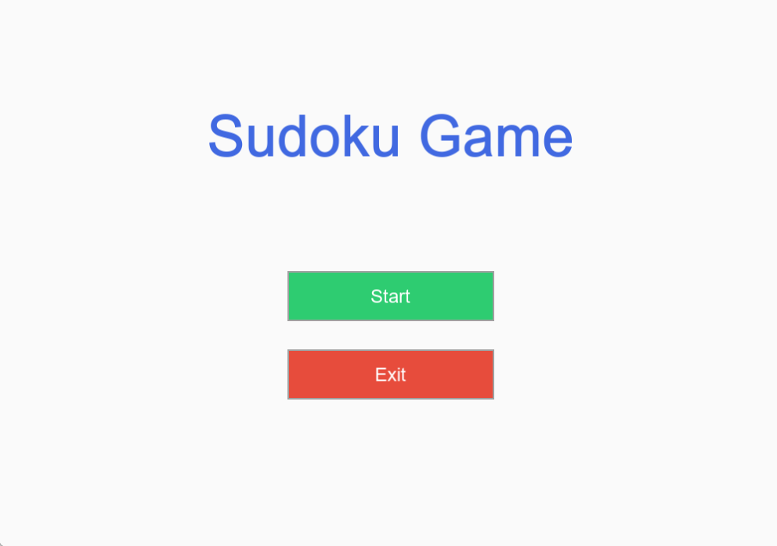
Figure 5.1: StartScreen

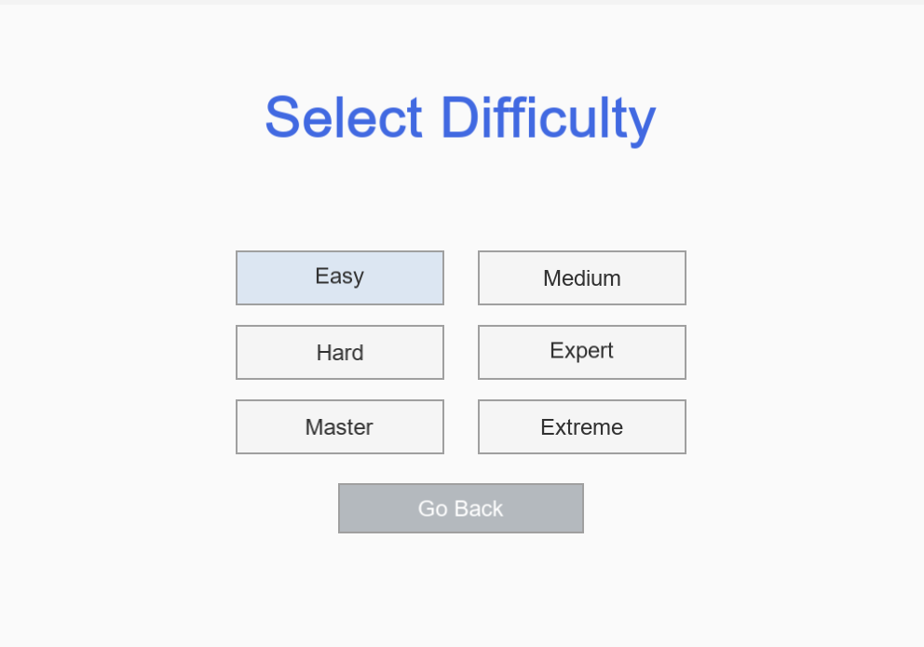
Figure 5.2: Difficulty Selection Screen
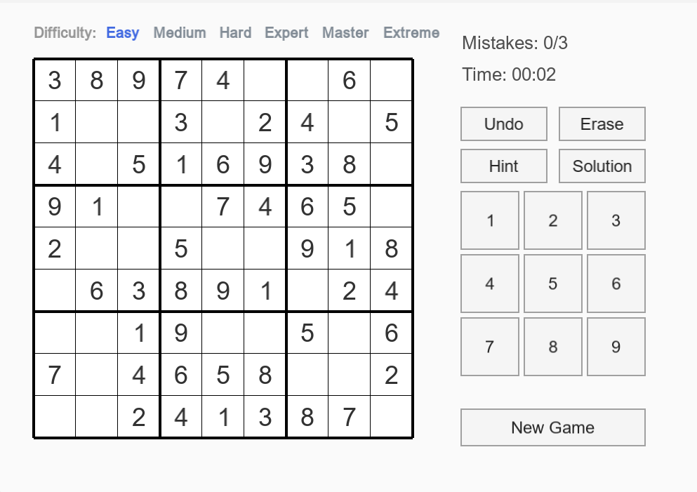
Figure 5.3: MainGame Screen
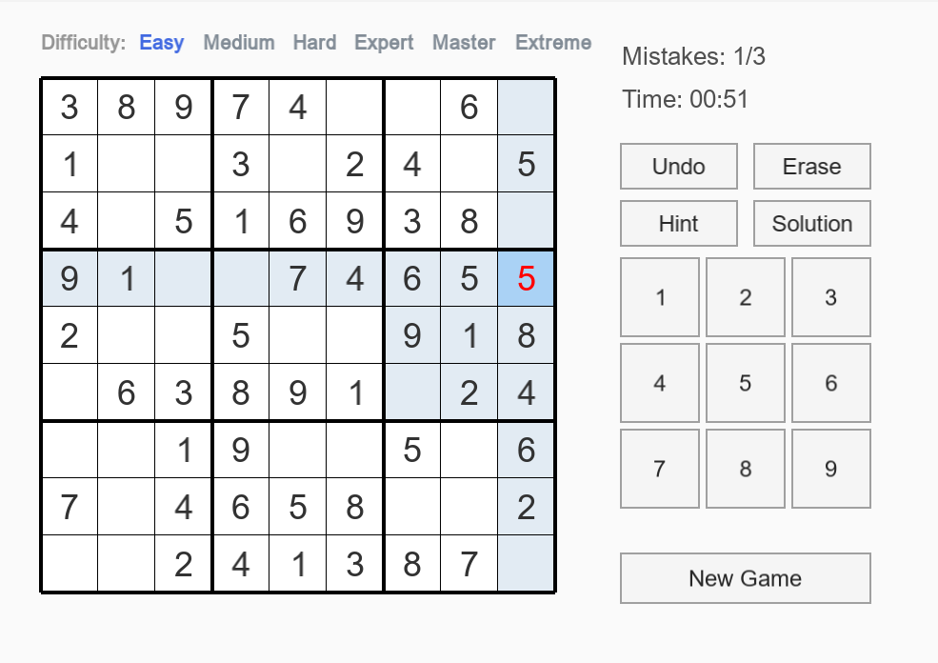
Figure 5.4: Wrong input from user interface

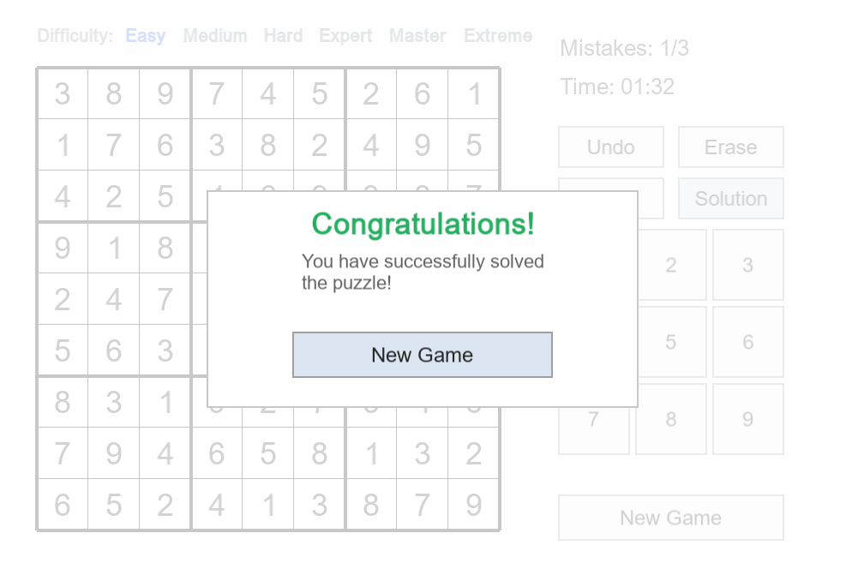
Figure 5.5: Win game screen

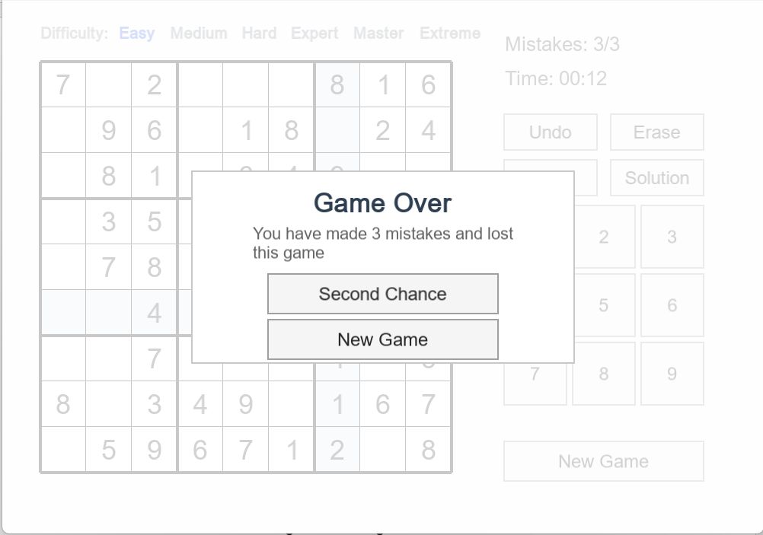
Figure 5.6: Game over screen

6. Implementation Details
- Core Classes (Board): Implements std::vector<MoveRecord> to track state changes. It also caches a secret mSolution array during generation to provide  error checking when the user inputs a number.
- Solver Classes (SudokuSolver): Employs a custom SolverStats structure. It calculates a scientific difficulty score using the formula: Score = (recursionCalls * 1) + (backtrackCount * 8) + (maxDepth * 15).
- Generator Classes (SudokuGenerator): Uses std::async to execute the heavy generation pipeline (Fill Dig Check Unique Evaluate) on a separate CPU thread, returning a std::future<Board>.
- GUI Classes (GameUI, SudokuGrid): Utilizes sf::Drawable for rendering and std::function (Callbacks) to decouple button clicks from the game logic.

7. Experimental Results

7.1 Solver Performance
Tested on 1000 generated boards.
- Easy/Medium boards: Solved in ms.
- Expert/Extreme boards: Solved in ms.
The bitwise MRV algorithm proved highly effective in eliminating the exponential time barrier.

7.2 Puzzle Generation Time
Due to the strict requirement of Unique Solutions, generating an "Extreme" board requires massive backtracking.
- Solution: Wrapping SudokuGenerator::generate in a background thread allowed the GUI to display a "Loading..." screen at 60 FPS without the operating system marking the application as "Not Responding".

7.3 Difficulty Statistics
The heuristic evaluation successfully mapped cognitive effort to difficulties:
- Easy: backtracks, empty cells.
- Expert: backtracks, requires advanced human techniques (e.g., X-Wing) to solve without guessing.

8. Challenges and Solutions

8.1 The std::bad_optional_access Crash
- Issue: During intense background generation, accessing a null std::optional cell caused fatal crashes.
- Solution: Applied Guard Clauses and utilized .value_or(1) to safely default values, preventing memory access violations without breaking the algorithm.

8.2 UI Thread Blocking
- Issue: Generating a "Master" board took ms, causing a noticeable frame stutter when clicking the difficulty bar.
- Solution: Implemented Multithreading (std::async). The main loop uses a non-blocking .wait_for(0s) polling method to check if the generator thread has finished.

8.3 State Data Integrity
- Issue: The AI's generation process recorded hundreds of moves into the user's mUndoStack.
- Solution: Implemented a prepareGame() function that flushes the undo history and freezes (is_fixed = true) the AI's generated cells before handing the board to the player.

9. Conclusion

9.1 Achievements
This project successfully bridged the gap between theoretical algorithms and practical application development. By replacing naive loops with Bitwise operations, sequential guessing with MRV Heuristics, and procedural code with a State Machine Architecture, the application achieves maximum efficiency and stability. It demonstrates a deep understanding of Time/Space complexity optimizations in C++.

9.2 Future Improvements
- Dancing Links (DLX): Replacing the AC-3 backtracking solver with Knuth's Algorithm X (Dancing Links) to further optimize exact-cover problem solving.
- Serialization: Adding File I/O to save and load game progress.
- Advanced Hints: Upgrading the Hint system to textually explain Sudoku techniques (e.g., "Hidden Single found at Row 2").

